HA
Development Approach
IPT WP 190

UNCONTROLLED DOCUMENT WHEN PRINTED
Printed versions of this document may not be at the latest revision level and users are advised to check with the master copy on DMS before use.
Remember – please avoid printing this document where possible to avoid wasting paper, if printed copy is required please print double sided and ensure it is recycled after use.
Documented based on Alcatel-Lucent UK&I standard document template no: 8BH 05000 0003 UFZZA v9.0

Document Author: Raj Wagh

Change History

Date | Version | Author | Reason
12/06/11 | Draft 0.1 | Raj Wagh | Document creation

Document Reference(s)

Reference  Number | Document Name | Document Purpose | Author | Date & Version

Glossary of Terms

The master copy of the Glossary and Abbreviations is located in DocuShare and can be accessed via the URL:

http://windex.ih.lucent.com/dsweb/Get/Document-560473/ISB%20Volume%206%20-%20Glossary.pdf

Contents
1 Introduction 4
1.1 Purpose 4
1.2 Background 4
1.3 Scope 4
2 Development APPROACH: IPT WP 190 6
2.1 Development PROcESS 6
2.1.1 Introduction to HA delivery Methodology 6
2.1.2 LLD Part2 Build Strategy 6
2.2 DEVELOPMENT SCOPE MANAGEMENT PLAN 8
2.2.1 Scope Planning – Development Plan Review 8
2.2.2 Scope Definition – Development Build – Unit Test Plan 8
2.2.3 Scope Verification – LLD Part2 Review Strategy 9
2.2.4 Scope Control – Development Build Strategy and Plan 10
2.3 Development TIme and Resource MAnagement PlAN 10
2.3.1 Activity definition 10
2.3.2 Activity Sequencing 10
2.3.3 Activity Resource Estimating 10
2.3.4 Activity Duration Estimating 11
2.3.5 Schedule Control 11
2.4 Development QUALITY MANAGEMENT 12
2.4.1 Quality Control 12
2.5 Development Reporting MANAGEMENt 13
2.5.1 Communication Process – Development and Unit Test Reporting Strategy 13
2.5.2 Information Distribution 14
2.5.3 Performance Reporting 14
2.6 DEvelopment RISK MANagement 15
2.6.1 Risk Identification, analysis and escalation 15
2.7 Resource structure for HA IPT WP 190 Development team 16
2.8 Dev Env set up and maintenance 16

Introduction

Purpose

The purpose of this document is to provide the development approach for IPT190. This will be followed by the development team through the complete lifecycle of development, from DR1 till DR2.

Background

This document focuses on the methods and procedures that will be followed by the development team to deliver IPT 190 for HA project.

Working of IPT
The IPT looks like IP Device to the LCC
The IPT looks like a Transponder to End Device

Primarily the IPT is simply a “Middleman”:
“Transponder” Functions are moved into the In-Station, as defined in the agreed
The IPT receives an IP message, Unwraps it and Forwards it on the RS485 path to the
End Device
The IPT receives a reply on the RS485 path, it Wraps it in the IP wrapper and
Forwards it to the LCC
For most messages this is the case however there are some messages where the IPT
has to handle the messages differently

Scope

This document will focus on the methods and procedures that will be used by the HA development team to develop and deliver the scope of work outlined by the LLD for IPT WP 190.
Below are the scope of the changes :-
- New Fault Management Interface between IPTNEM and Netcool (using existing
or new SNMP Probe in Netcool, import of IPT Enterprise MIB, Alarm Enrichment
and Correlation)
- IPT specific Network Topology and Inventory ,Service Configuration and
Provisioning capability build in Circee
- New maintenance and Inspection Profiles in D7i
- Potential Integration of PDAT (Performance Data Analysis tool) with Website.
- Netcool-Circee Interface ,Netcool-APM interface , APM-Circee Interface ,
Circee –D7i interface may require enhancements (e.g New data, Potential
schema updates to existing tables or new tables)
- Potential impact to Halogen-Netcool Interface (decommissioning) and other
systems such as PAMS, Website, DMS, Reporting, Fwd. Prog. etc to support
migration and phase out of Legacy Transponders to IPT.

Development APPROACH: IPT WP 190

Development PROcESS

Introduction to HA delivery Methodology

The HA development team will be following the OSS lifecycle process for development. We will adopt the development techniques that are appropriate to HA while allowing it to be productive with minimal overhead. We will be flexible to modifying or adapting this to the projects needs as it changes, if required.

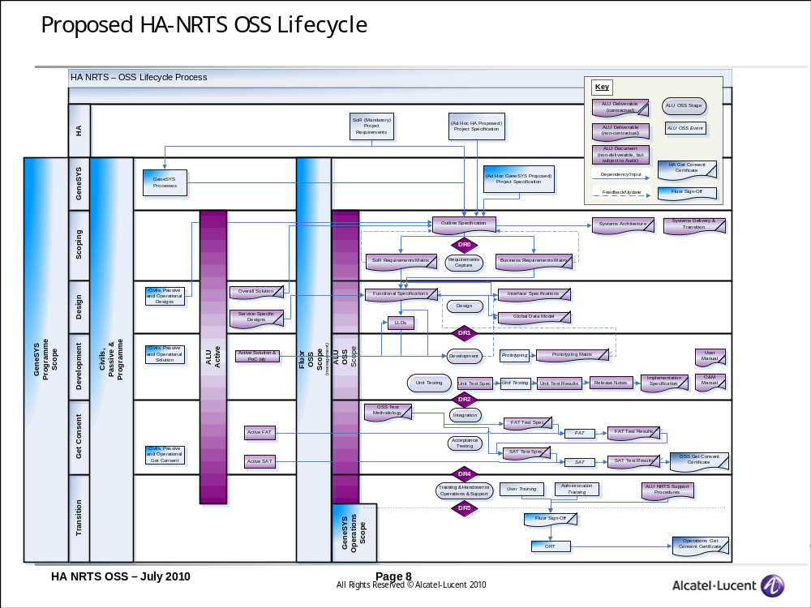

LLD Part2 Build Strategy

Basically a LLD Part 1 will be followed by an implementation design LLD P2 structure of which will be as follows.

1 Introduction 7
1.1 Purpose & Scope 7
1.2 Exclusions 7
1.3 Background 7
1.4 Risks 8
1.5 Assumptions 8
1.6 Issues 8
1.7 Dependencies 8
1.8 Constraints 8
1.9 Links & References 9
1.10 Acronyms & Terms 9
2 General Description 10
2.1 Subsystem Architecture 10
2.2 Subsystem Element Description 11
2.2.1 Netcool Probes 11
2.2.2 Impact 12
2.2.3 WebTop 12
2.3 Subsystem Function Description 12
2.3.1 <<<BBB>>> Probe 12
2.3.2 <<CC>> Probe 12
3 Impact 13
4 Webtop 13
5 Implementation Design Traceability 15
5.1 Traceability to Functional Requirements 15
5.2 Traceability to Detailed Design (LLD Part 1) 17
6 Subsystem Common Design 19
6.1 Physical Data Model 19
6.2 Integration Class Design 19
6.3 Physical Interface Design 20
6.4 User Interface Design 20
6.5 Software Class Design 20
6.6 Configuration Design 20
6.7 Component Activity Design 20
6.8 Deployment Node Design 21
7 COTS System Element Design 22
7.1 System Element <aaaaa> COTS Design 22
7.1.1 Purpose and Function 22
7.1.2 COTS Products Protocols, Standards and their Customizations 22
7.1.3 Data Customization Design 22
7.1.4 Component Structure Customization Design 22
7.1.5 Component Activity Customization Design 22
7.1.6 User Interface Customization Design 23
7.1.7 Configuration Design 23
7.1.8 Report Design 23
7.1.9 Templates 23
8 Appendices 24

This allows the project team flexibility to produce implementation design, and at the same time be adaptive to rapidly changing or highly emergent requirements.
However, since HA is a fixed price project, the requirements and the design will be signed off and finalized before development starts.

DEVELOPMENT SCOPE MANAGEMENT PLAN
The scope of development will be defined by the LLD part 1 handed over by the Design team to the development team.

Scope Planning – Development Plan Review

Inputs : LLD Part 1

Process : To define the scope of development, the development team starts by looking at the HLD and the requirements that are available and starts the process of analysis. A rough effort estimate is made based on the HLD and requirements available. This is done before the LLD is ready, so that the development team can have early visibility to the scope defined by requirements and design. No commitments are made at this time.
When the LLD is sent to the customer for review and feedback received we will do a SDR2. The development team will also clearly list the dependencies, assumptions and risks.

In the interest of time the development team does scope planning once the LLD is sent to customer, but before it’s finally signed off. The time estimated between LLD sent to the customer and receiving a sign off is estimated to be 2 weeks of time. If in this 2 weeks, the LLD is changed the changes will need to be accounted for.

Output : LLD Part 2

Scope Definition – Development Build – Unit Test Plan

Input : Development planning meeting

Process : The scope of the work package will be defined by the following
- List of Deliverables other than code (documents, unit test cases, release pack etc)
- Complete list of Assumptions, dependencies
- Complete list of Risks and Issues

This will be defined in the Development planning meeting, and will be fine tuned after the LLD is signed off.

The scope definition can finally be locked, after the official handover of the LLD happens between design and development team, post LLD sign off in SDR3. The following flowchart defines that process.
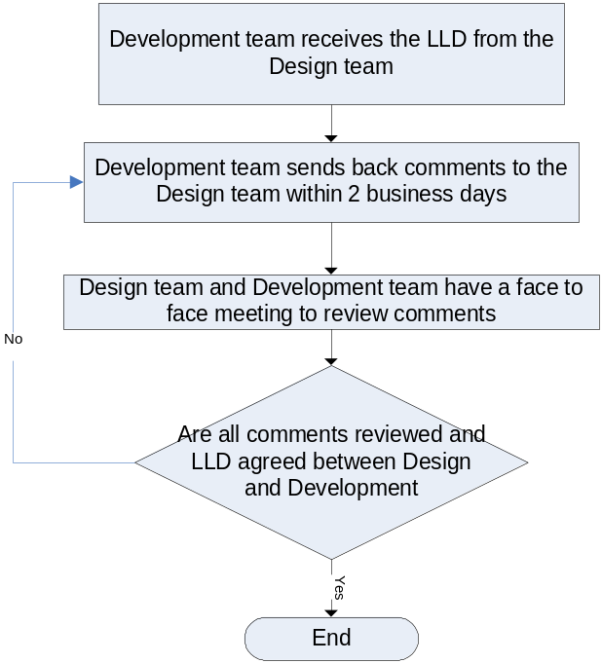

Finally the development team will attend the formal SDR session called by the TPM, where the scope of development and all the following items can be validated to get the project management’s consensus on scope.
- List of Deliverables other than code (documents, unit test cases, release pack etc)
- Complete list of Assumptions, dependencies
- Complete list of Risks and Issues

Output : Development scope for a particular drop

Scope Verification – LLD Part2 Review Strategy

Input : Development scope

Process : In the beginning of a this phase the criteria is pre decided. This could be any or all of the following items:
- List of Deliverables other than code (documents, unit test cases, release pack etc)
- Complete list of Assumptions, dependencies
- Complete list of Risks and Issues

Once the development phase is complete a LLDP2 review meeting is called, and the team goes over the predefined checklist. Only if all items are checked, the LLD P2 is considered complete.

Output : Accepted deliverables, not accepted deliverables with reasons.

Scope Control – Development Build Strategy and Plan

Input : Approved change request impacting development scope.

Process : Once the scope of development is agreed in the SDR 3, no change requests will be taken into account unless it goes through the change management process at the project level and in approved. In this case the development team will call for a development planning meeting and will access the magnitude of variation.
If the change request requires additional development, the team will add these new tasks in the project plan. The list of assumptions, dependencies and risks will be updated. The List of deliverables will be updated, if necessary.

Output : Updated development scope.

Development TIme and Resource MAnagement PlAN

Activity definition

Input : LLD, L3 Project Plan, Environment factors.

Process : During the Development planning meeting, the development team take the LLD as an input and product a list of high level task in the project plan. The project plan is used to create a Development plan, for all the Developments required in that drop. The Development plan will have the deliverables at the lowest level of development work. It is this list of activities that will provide the basis of estimating, scheduling, executing monitoring and controlling. This is done through the lifecycle of the Development and at the end of the Development in the Development review meeting.

Output : Activity/ task list in the Development plan, milestone list

Activity Sequencing

Input : Project plan, Development Plan, Milestone list

Process : The Development lead will produce a project plan in Microsoft office that will list of the sequence in which the tasks will be carried out in the Developments. This will clearly mark all dependencies as required milestones and will show the relationship between predecessor activities and successor activities

Output : Project plan

Activity Resource Estimating

Input : Requirements, HLD, LLD, L1 project plan, Development plan, environment factors, resource availability

Process : The development team needs to estimate resources in terms of persons, equipment, material etc in time for timely delivery. Following is the diagram depicting the development process between DR1 and DR2. The resource estimate for development starts will be included in resource plan.

DR1 Preparation
During the DR1 preparation the development lead will use all available information (requirements, HLD, resource availability, environment factors) whether complete or incomplete and prepare for the DR1 where based on information available, the following will be secured

- Developers
- Dev Env
- Software licences
- Network Dependencies
- Other resourcing requirements specific to that drop

Since the signed of LLD is not ready when the DR1 occurs, the above list is secured by the dev lead with the information available.

Once the LLD is close to final and sent to the customer for sign off, the development team meets for a Development planning meeting. Here the development scope is updated with any new information in the LLD and so is the list of resourcing

The above list is finalized in the SDR meeting, after which the Developments start.

Output : Resource requirements (persons, equipment, material), resource calender

Activity Duration Estimating

Input : Project plan, Resource requirements, resource calendar, organizational processes, Environmental factors

Process : The effort estimates were done during the Development planning meeting. This combined with the output of Activity resource estimating, environmental factors and organizational processes will produce a project calendar specifying the development duration for a drop.

Output : Microsoft office duration project plan

Schedule Control

Input : Project plan, Approved Change request, Development Plan

Process : Schedule Control will account for the following
- Determining current status of the development – The development team will have daily status meetings, where each days development status is tracked and the Development team will update the Development burn down chart with this information. This is will give a quick a clear view of the current status of the development on a daily basis and any deviation from the baseline can be easily and quickly identified. The baseline will be agreed in the SDR gate before development for a particular drop starts.
- Progress Reporting : This will be done by means of Development Project Plan at the end of a Development and release Project Plan at the end of all the Developments for a drop. Wherever necessary the dev lead will also provide a project plan.
- Managing change requests : Once the Developments have started, changes to scope will only be accommodated if it has gone through the programs official change management process. This will require analysis and may cause update in project plan, and the Development plan.
- Variance Analysis and Comparison Charts : The development lead will regularly do comparisons of target dates with actual start and finish dates. This will provide good input on the variance of actual versus projected and corrective actions can be taken in case of delays. The development team lead will regularly compare the actual Project Plans with the baseline Project Plans that will graphically represent where the schedule progressed as planned and where slippage has occurred.

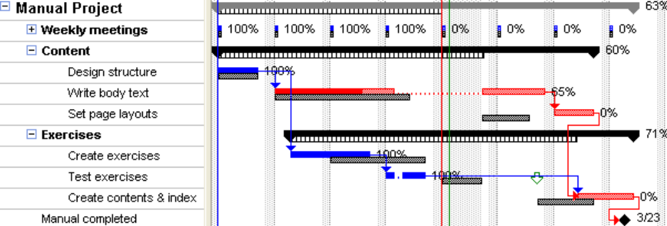

The work progress of actual against baseline.

Output : Development Project Plan, Release Project Plan, Requested changes (may result in updated project plan),Recommended corrective actions, Comparison chart.

Development QUALITY MANAGEMENT

Quality Control

Input : DR1 checklist, SDR checklist, LLD handover between design and development, Development reviews, coding standards

Process : This will include applying systematic quality activities to ensure development meets the quality standards.
- DR1 and SDR Gates : The development lead will go through the checklists in the DR1 and SDR gates to make sure all the necessary requirements are in place for development to continue till the DR2 gate in reached.
- LLD handover between design and Development – The process of handover between development and design explained in the earlier section, ensures the development team understands the contents of the LLD and considers it complete. This ensures there is no ambiguity around the scope of development after development starts.
- Coding and unit test cases – The development team will be following the project life cycle method in which code and unit test cases are completed and ensure any issues can be identified and removed quickly.
- Development Acceptance Criteria– In the Development planning meeting, the list of items that need to be checked to consider a Development complete, is pre decided. At the end of every Development, the development team goes over the Development checklist to ensure these items are all checked before declaring a Development complete. This could be unit test passed, build completed, items from Development plan completed etc.
- Comparison Charts – The Development lead will be preparing comparison charts regularly. At the end of the Development review meeting the Development lead will prepare a comparison chart that will graphically represent, actual versus baseline. This will graphically represent where the schedule progressed as planned and where slippage has occurred. The reasons of slippage can be analyzed and corrective measures put in place.
- Coding Standards – Website and Netcool will both have a set of coding standards documented before development starts. The development team will adhere to these coding standards as much as possible.
- Quality Center Defect Tracking – The quality of the code will also be measured by the number of defects that are opened in the Quality Center during the testing cycle. All attempts will be made to minimize the number of defects.
- Regular builds – The development team will be taking regular builds in every Development wherever it makes sense. This will ensure that complete functional components of code are being produced and that is the free of errors.
- Code and Document Repository – All code and documentation will be version controlled and stored in SVN and Docushare.
- Document Quality Control - All development documentations will go through 2 internal review cycles with a span of 5 day each. This will ensure proper peer review is done and document is updated with review comments.
- Testing Acceptance Criteria – The development team lead will participate in the DR2 gate that will ensure all the acceptance criteria is fulfilled before a release pack is handed over from development to testing.
- Code and Database backup – To ensure that code and database can be recovered if the need arises, the development team will have a dependency on the integration team to ensure that SVN and database is backed up regularly. (need to decide backup frequency)

Output : Checklist of DR1, DR2, SDR, Development reviews, coding standards, comparison charts, defect list, code and document repository.

Development Reporting MANAGEMENt

Communication Process – Development and Unit Test Reporting Strategy
Input : Project Environment Factors, Organizational Processes, Project Management Plan

Process : The development team will be able to communicate with other at any point or time through emails, phone calls or face to face meeting. However, the following are official communication processes that will be put in place.

DR1, LLD handover, Development Planning Meeting, SDR, Daily Status meetings, Development Review Meetings, DR2 – All these are defined in detail earlier in the document

Output : inter and intra team meetings

Information Distribution

Input : SVN, Docushare

Process : All information (code and documents) will be stored in docushare or SVN. Information will also be shared via email, phone and face to face meetings.

Output : Documents, Code, Performance Reports, Presentations, Feedback and Review comments.

Performance Reporting

Input : Daily status meeting, project review meeting

Process : This will involve distribution of performance information to stakeholders. Performance reports will provide information of scope, schedule and quality. Also status reports, risk register, dependencies will be communicated.

Development Project Plans – This will provide insight to the developments team daily work status.

Release Project Plans – This will provide insight to the development teams performance for the whole drop, or everytime there is a DR2 scheduled.

Comparison Charts – This will provide insight to whether the development team’s performance is aligned with the baseline or whether it has a deviation from the baseline. Done at the end of every drop, or whenever a DR2 is scheduled.

Weekly Status Reports – This will highlight risks, issues, dependencies, and roadblocks to the project management every week.

Project Plan – This will keep track of the whole development cycles duration, milestones, resource utilization and will link tasks in terms of predecessor and successor tasks.

Output : Performance reports listed above

DEvelopment RISK MANagement

Risk Identification, analysis and escalation

Input : LLD, Project plan, Development Plan, Environment factors, Project Plan

Process : Risks will be identified as early as possible in the development cycle and escalated with the right attributes to the project management using Online risk register. However, risk identification is an iterative process and the development team will be going through this exercise for every Development.

The development team will undergo risk analysis for the first time during the DR1 preparation with the information available. The risk register is updated and this will be presented during the DR1 meeting.

Once the LLD is sent to the customer and is in close to final stage, the development team will undergo the risk analysis one more time and will update the risk register. During the Development planning meeting the risks are identified for each Development. This final list of risks, before development of a particular drop starts is presented to the project management during the SDR.

The status team will have an opportunity to notify the Development lead of risks/roadblocks/dependencies everyday, during daily status meetings and the Development lead will update the risk register. These risks (depending on nature of risks, its effect on the schedule and escalation required) will either be notified to project management immediately or during the weekly status meetings.

Output : Risk Register

Resource structure for HA IPT WP 190 Development team
HA - OSS Project Organisation
Development
Lead
(Raj Wagh)
ALU
Programme Lead
(Thom Scholtz)
Test Leads
(Mark Gilby
& Nilesh Deotale)
Development Team
OSS
Release, Integration
& Deployment Consultant
(Eric Rainer)
OSS/BSS Lead TPM
(Miles Taverner)
Governance
Independent Quality
Management
(David MacAfee)
Governance
(Dharminder Bagha)
SIT and E2E
Test Team
Design Team
(UK & FR)
Governance
Steering Committee
Programme Governance
Independent Technical Governance
Team from
Development
(Ext & IS France)
OSS/BSS TPM
(Marco Valdivia)
Team from
Test Partners (External)
Lead NW Solution
Architect
(Mark Prosser)
Solution Design Authority
(tbd)
Design Lead
(tbd)
Analysis Lead
(Hunter Barr)
Network TPM
(Bob Hall)
Lead OSS Solution
Architect
(Greg Dart)
Configuration and Integration Team
CTA
(?)
Information Analyst
(tbd)
SDF Lead
(?)
OSS Support
Structure
(see next
slide)

Dev Env set up and maintenance
The development environment will consists of a development environment and a development deployment environment. Coding/Configuration/Workflows will be done in the development environment and unit tested there.
Once unit testing is complete, a build is created and deployed in the development deployment environment. This will test that the build can be successfully deployed. The development deployment environment will also be used to perform a final smoke test of functionality being delivered in that build.
Once the build has been tested and the code has been smoke tested, the build along with release notes in handed over to the test team for testing via SVN.

Each developer will also have any clients installed on the individual laptops.
Assumptions
Functional Area | Responsibility | POC
Application software, code and anything on developer laptop, (install, maintenance and backups) | Development team | Developer
Configuration and developed code on development environment (install, maintenance and backups) | Development team | Development team
COTS software in development environment (install, maintenance and backups) | Integration team | Eric Rainer
OS in development environment (install, maintenance and backups) | Integration team | Eric Rainer
Development Server Maintenance related to hardware, disk space, performance etc | Integration team | Eric Rainer
Issues related to network connectivity in the development environment | Integration team | Eric Rainer
Issues related to Network Elements and EMS. Configuration information from the EMS that will be required to configure interface from Axioss | Integration team | Eric Rainer

